**10.File Operations**

Learning Objectives: By the end of this chapter, you should be able to:

* Explore the filesystem and its hierarchy.
* Explain the filesystem architecture.
* Compare files and identify different file types.
* Back up and compress data.

Introduction to Filesystems: In Linux (and all UNIX-like operating systems) it is often said “Everything is a file”, or at least it is treated as such. This means whether you are dealing with normal data files and documents, or with devices such as sound cards and printers, you interact with them through the same kind of Input/Output (I/O) operations. This simplifies things: you open a “file” and perform normal operations like reading the file and writing on it (which is one reason why text editors, which you will learn about in an upcoming section, are so important).

On many systems (including Linux), the filesystem is structured like a tree. The tree is usually portrayed as inverted, and starts at what is most often called the root directory, which marks the beginning of the hierarchical filesystem and is also sometimes referred to as the trunk, or simply denoted by /. The root directory is not the same as the root user. The hierarchical filesystem also contains other elements in the path (directory names), which are separated by forward slashes (/), as in /usr/bin/emacs, where the last element is the actual file name.

In this section, you will learn about some basic concepts, including the filesystem hierarchy, as well as about disk partitions.

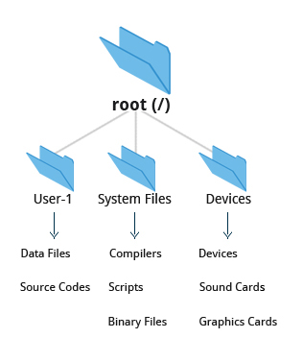

Fig: Filesystems

Filesystem Varieties: Linux supports a number of native filesystem types, expressly created by Linux developers, such as:

* ext3
* ext4
* squashfs
* btrfs.

It also offers implementations of filesystems used on other alien operating systems, such as those from:

* Windows (ntfs, vfat)
* SGI (xfs)
* IBM (jfs)
* MacOS (hfs, hfs+).

Many older, legacy filesystems, such as FAT, are also supported.

It is often the case that more than one filesystem type is used on a machine, based on considerations such as the size of files, how often they are modified, what kind of hardware they sit on and what kind of access speed is needed, etc. The most advanced filesystem types in common use are the journaling varieties: ext4, xfs, btrfs, and jfs. These have many state-of-the-art features and high performance and are very hard to corrupt accidentally.

Linux Partitions: Each filesystem on a Linux system occupies a disk partition. Partitions help to organize the contents of disks according to the kind and use of the data contained. For example, important programs required to run the system are often kept on a separate partition (known as root or /) than the one that contains files owned by regular users of that system (/home). In addition, temporary files created and destroyed during the normal operation of Linux may be located on dedicated partitions. One advantage of this kind of isolation by type and variability is that when all available space on a particular partition is exhausted, the system may still operate normally.

The pictures shows the use of the gparted utility, which displays the partition layout on a system which has three operating systems on it: RHEL 8, CentOS 7, Ubuntu and Windows.

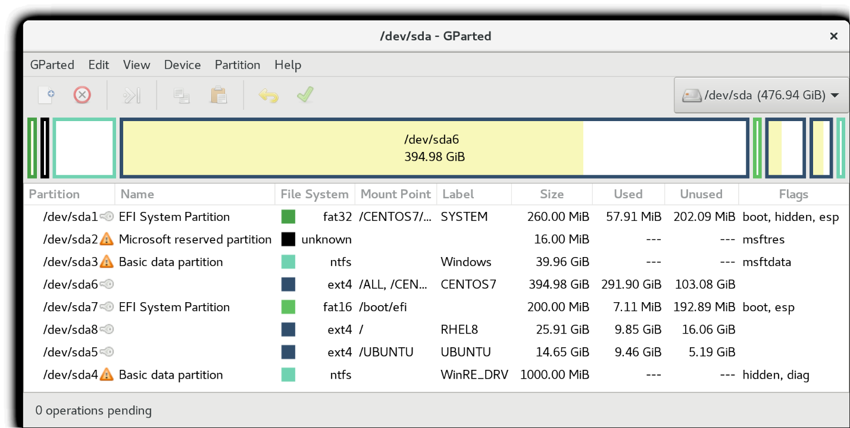

**Linux Partitions: gparted**